Analyzing and Visualizing WeRateDogs

***Introduction:***

Have you heard about one of the most famous meme of 2016 “they’re good dogs Brent” and the twitter account WeRateDogs? Probably yes, but if not.Here I can tell you a bit about it and better than that I can show you some fun analysis of WeRateDogs tweets data. First, WeRateDogs is a Twitter account that rates people's dogs with a humorous comment about the dog. These ratings almost always have a denominator of 10. The numerators however are almost always greater than 10 (11/10, 12/10, 13/10, etc.). In theory the rates should be 1 to 10. However, WeRateDogs disagree, they admit almost all dogs deserve a 10 and sometimes more than that. WeRateDogs has over 6 million followers and has received international media coverage. One of those coverage were about the quote “they’re good dogs Brent”, this was an exchange in which WeRateDogs shut down a person having an issue with its rating system in humorous ways. So what does this rating do? Which dog type (breed) is most common dog in the tweet dataset? What dog type has the highest average rating? These questions and more are answered in the following insights:

1. ***Which breed gets retweeted and favorited the most overall***

The dogs displayed in the images are mostly golden retrievers with a count of 154 or labrador retrievers with a count of 105.(figure below)

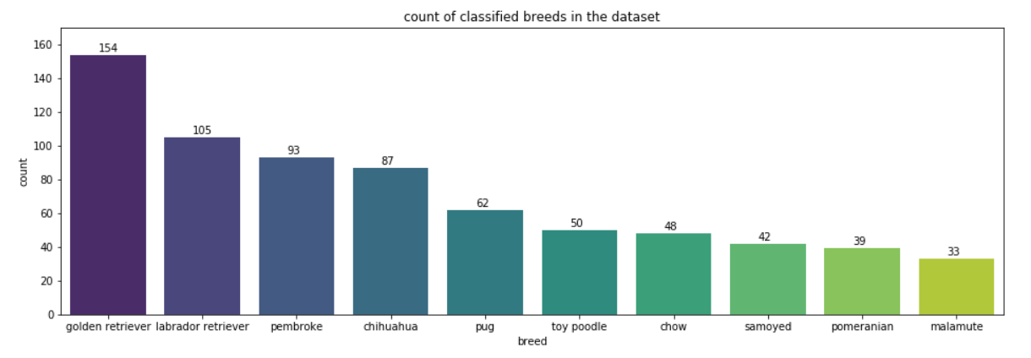

let's look at the most retweetet and favorited single tweet.

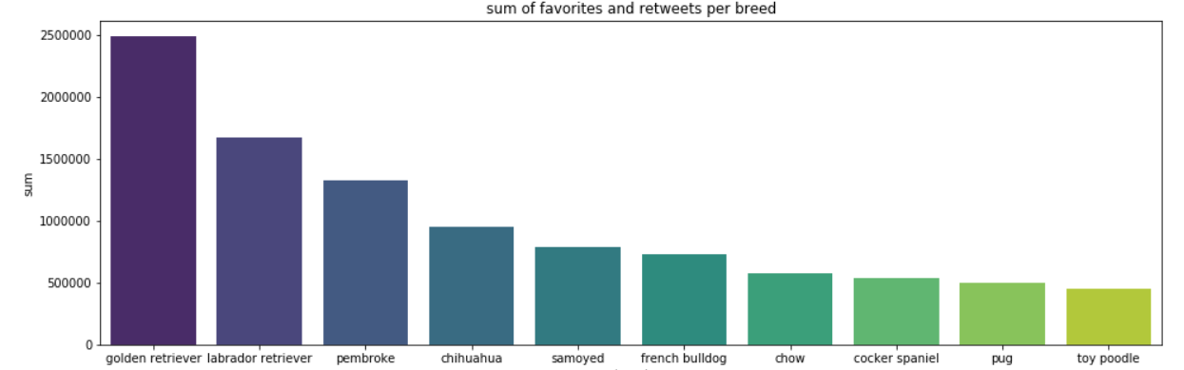

We can see that the most liked and retweeted tweet is in fact a labrador retriever, with golden retrievers not even being in the list. Let's see if there are big differences in the average rating.

**2. How did the account develop (speaking about number of tweets, retweets, favorites, image number and length of the tweets)?**

First We extracted time information out of the timestamp.

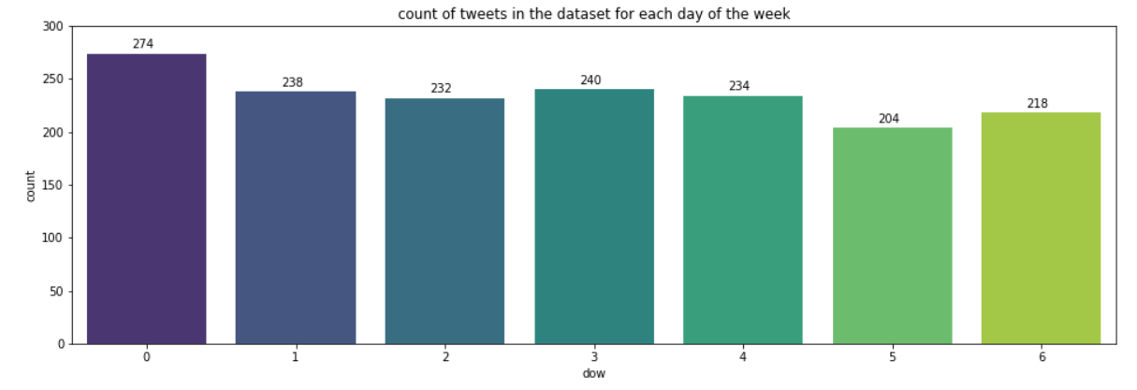

most of the tweets are posted on monday. For tuesday to friday it is nearly the same number of posts. On the weekend the Twitter profile tweets a little bit less.

-----------------------------------------------------------------------------------------------------------

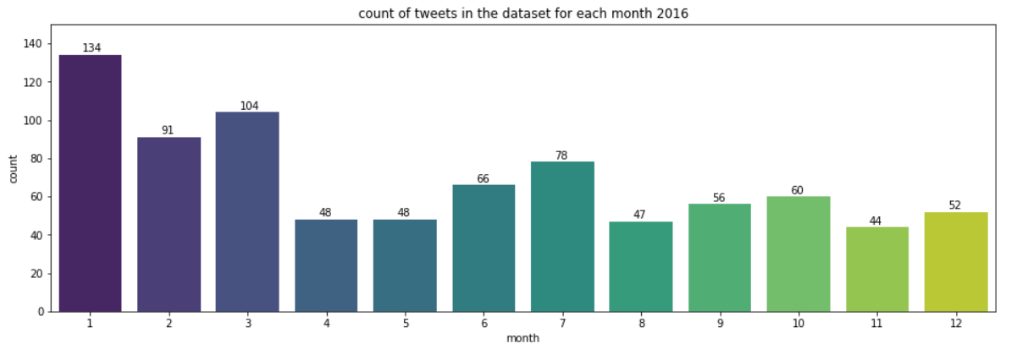

Over the timeperiod of 2016 the number of post per months decreased. It went from 134 tweets in January to 52 in December. Does this mean, that the performance of this account is also decreasing.

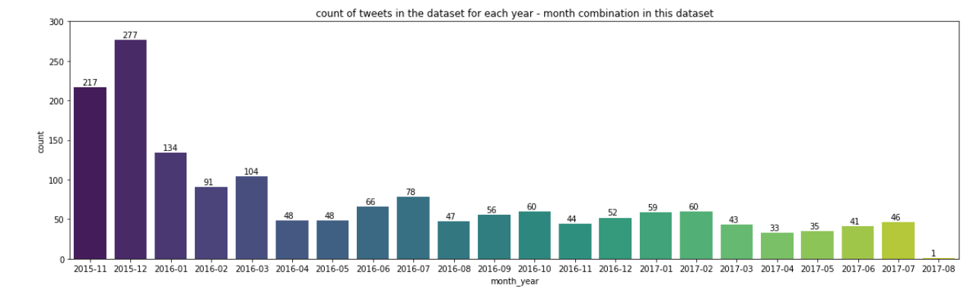

we look at it over the whole timeperiod it becomes even more clear. In April 2016 the number of tweets dropped and since then it has a relatively stable level. To see if the performance of the Account decreased we will take a look on the favorites and retweets that the posts get.

---------------------------------------------------------------------------------------------------

***3-pattern visible in the timing of the tweets?***

ount of tweets in the dataset for each hour in 2016

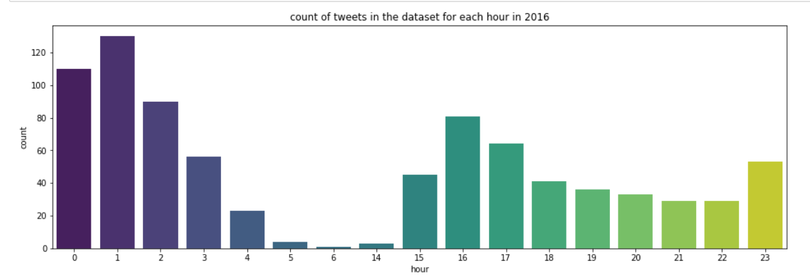

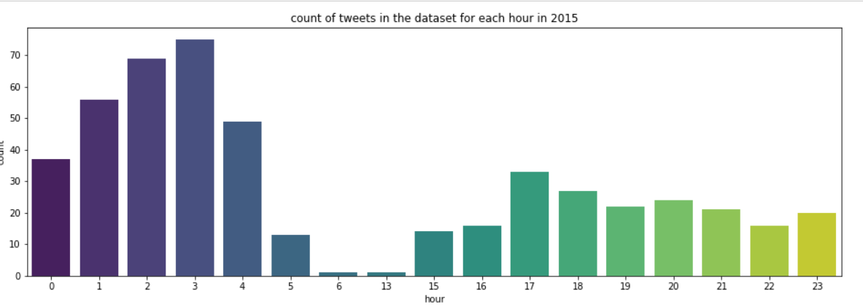

we can see in this graphs of 2015 and 2016, the most posts are during the night between 0 (inlcuded) and 5 'o clock. between 4 and 15 'o clock there is a very small amounts of tweets, in fact there is no single tweet for the hours 7 - 12 and 14 o' clock. There are some tweets after 14 'o clock, but not as much as between 0 (included) and 5 'o clock.